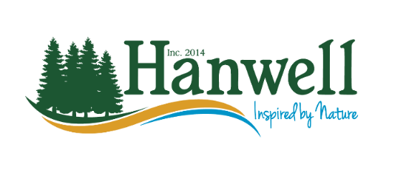

**To: Residents of the Yoho Lake Area**

On behalf of the Hanwell Emergency Measures Organization Committee (EMO) and the Yoho Lake Association (YLA) we are pleased to advise our residents that we will be conducting a survey to assist us with Emergency Preparedness.

Over the next couple of weeks, members of the Yoho Lake Association will be going door-to-door dropping off or picking up a questionnaire.

As you are aware, we are in wildfire season and the province is requiring local governments (municipalities) to have a Wildfire Evacuation Plan in place. This questionnaire will be beneficial during the wildfire season but also during the fall and winter as we certainly remember the damages and power outages from the December 2023 storm.

As per the ***Rights to Information and Protection of Privacy Act***, section 43(3) A public body shall limit the use and disclosure of personal information in its custody or under its control to those of its officers, directors, employees or agents who need to know the information to carry out the purpose for which the information was collected or received or to carry out a purpose authorized under section 44.

Section 44. A public body may use personal information **only**; (d) if the individual the information is about has consented to use or section 46(1)(h) if necessary to protect the mental or physical health or the safety of any individual or group of individuals.

Questionnaires (found on the other side of this letter) can be dropped off at the Hanwell Municipal Office, or take a picture of the form and email to [CAO@hanwell.nb.ca](mailto:CAO@hanwell.nb.ca) (Terri L Parker), or provide to any member of the Yoho Lake Association (YLA)

Our intention is to keep our residents safe, and the more we know, the more we can assist.

**Be Aware - Be Proactive - Be Safe**

Regards,

Scott Targett Terri L Parker  
President- Yoho Lake Association CAO/EMO Coordinator- Hanwell