New Brunswick Alliance of Lake Associations

Boat Inspection Package

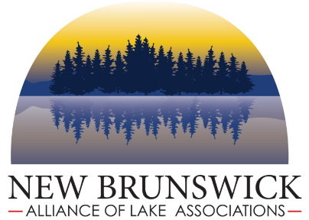

  - What are invasive species?
The introduction of non-native invasive plant and animal species to North America has been escalating with widespread destructive consequences. The impacts of the spread of invasive plants are well known: habitat disruption, loss of native plant and animal communities, reduced property values, impaired fishing and degraded recreational experiences, and enormous and ongoing control costs.
With over 2500 lakes in New Brunswick, the task of preventing the spread of invasive plant species in New Brunswick freshwater is a serious environmental challenge. Invasive plants are moved about in complex and often unseen ways. The speed which a new invasive species can explode into an ecologically and economically disastrous infestation is well documented. Once an invader is well established, eradication is extremely difficult and costly, if not impossible.
Prevention is the first step to fighting this invasion, but no matter how comprehensive and aggressive the prevention effort is, chances are some invasive organisms will slip through the cracks. In such cases, it is crucial that the invaders are detected as early as possible, before they have had an opportunity to cause significant damage or to spread to other waterbodies. Early detection provides the best hope of eradication.
  - What is a boat inspection?
Boat inspection consists of visually inspecting all areas of boating and recreational equipment (i.e., boat, trailer, motor, live well, anchor, swim fins, scuba gear, etc.) that come in contact with or hold water; removing all visible plants, animals, and mud; and draining water from all compartments and containers. These practices reduce the risk of movement of all organisms from one body of water to another. The purpose of watercraft inspection is to:
• Reduce the impact of AIS on native aquatic organisms and ecosystems
Courtesy Boat Inspections:
- Clean off any mud, plants (even small fragments) and animals from boats, trailers and equipment.
- Drain boat, live well, engine and equipment away from the water.
- Dry anything that comes into contact with the water.
- Never leave waters with live fish, or release plants or animals into a body of water unless they came out of that water.

Additional consideration(s):

- Always check trailered boats prior to arriving to the launch to ensure their bilge and live wells are drained (and better, dry!) prior to launching the boat in the water.
- Check jet boats and personal watercraft (PWCs) intake grates.
- Run the engine for 5-10 seconds to blow out excess water and vegetation from internal drive before leaving the water.
- Encourage boaters to dry the boat and equipment between use in different lakes

• Limit or prevent the spread of AIS by containing infestations to current locations
• Increase boater awareness about ways they can help prevent the spread of AIS
A watercraft inspection program is an outreach tool utilizing paid and/or volunteer stewards to engage and teach boaters how to inspect boats, trailers, and recreational gear for unwanted aquatic hitchhikers, and to properly remove and dispose of those hitchhikers. While voluntary watercraft inspection is common at some launches, regulations overseeing the removal and proper disposal of hitchhiking debris and organisms is increasing across New Brunswick.

Why should we care about invasive species

in our waterways?

- Economic consequences
The federal, provincial, and local costs to manage AIS increase each year as AIS populations continue to grow and spread. Infestations of AIS that limit recreation, clog waterways, prevent boating, and obstruct water pipes may impact the value of public and privately-owned property.
- Recreational consequences:
With the ability to grow faster and reproduce more frequently than many native aquatic species, and lacking natural predators, AIS can overwhelm the natural habitats. Aquatic invasive plants can form dense mats of vegetation, making it difficult or impossible to boat, swim, or fish.
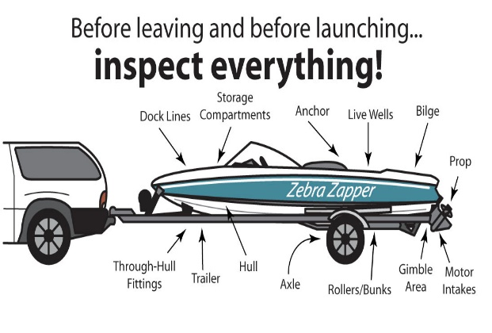
- Environmental and ecological consequences:

AIS can out-compete and displace native species, disrupting food webs and altering native aquatic species population abundance and composition. These ecosystem changes may make once suitable habitat less favorable for native aquatic animals such as sport fish and macro invertebrates.

