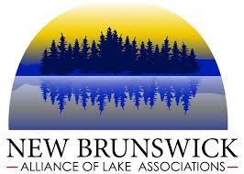

Dear NBALA Representatives,

The New Brunswick Alliance of Lake Associations would like to formally invite you and your members to attend our Annual General Meeting and our 4th Annual Lakes Conference on Saturday, November 2nd beginning at 8:30 AM. This will take place at the Riverside Resort in Mactaquac, New Brunswick. We will begin the day with our Annual General Meeting and provide brief status updates on our projects under the Environmental Trust Fund funding as well as hold formal elections for the executive roles. As discussed at our previous meeting held in the Spring, we will be holding a lakes conference this year, entitled Understanding Climate Impacts on Lake Ecology which is scheduled to kick off at 10 am. Topics we hope to cover include climate change impacts, the spread of invasive plants and species, cyanobacteria blooms and improved septic system management practices. We will conclude the conference around 3PM with a Panel Discussion of our hosted speakers. A light lunch and coffee will be provided. We hope you can attend and if you have any questions or concerns, they can be directed to the Conference Committee Chair Theresa Glanville (ntglanville@gmail.com), the NBALA Chair Sheryl Bartlett (Sheryl.anne.bartlett@gmail.com), or the NBALA Program Manager Briana Cowie (bcowie@ecw.ngo).

